OJUG Bioinformatics Presentation Resources Document

**Some Bioinformatics Online Tools and Tutorials**

* **BioJava:** <http://biojava.org/>
* **NCBI:** <https://www.ncbi.nlm.nih.gov/>
  + **NCBI Tutorial:** <https://www.youtube.com/watch?v=hTTvq8KJthA>
  + Can be used to grab sequences (mRNA, DNA, genes, etc). For example: <https://www.ncbi.nlm.nih.gov/nuccore/NM_000520>
  + Can be used for sequence alignment: BLAST – Huristic algorithm that performs sequence alignments; most widely used program for aligning sequences within a large database
  + NCBI Blas Search Tutorial: <https://www.youtube.com/watch?v=rlK-5joOlyU>

|  |  |  |
| --- | --- | --- |
| Program | Database | Query |
| Nucleotide BLAST | Nucleotide | Nucleotide |
| Protein BLAST | Protein | Protein |
| Blastx | Protein | Nucleotides -> Protein |
| Tblastn | Nucleotide -> Protein | Protein |
| Tblaxtx | Nucleotides -> Protein | Nucleotide -> Protein |

* **EBI (European Bioinformatics Institute)**: <http://www.ebi.ac.uk/>
  + Tools that implements local and global alignment methods
* Tutorial: <https://www.youtube.com/user/EBImedia>
* **T-REX** (MAFFT AND PHYML) - h <http://www.trex.uqam.ca/>
  + Can be used to create phylogeny trees based on phylogeny, not just sequence alignment
  + Here is a blurb from a research paper I wrote a while back:

“MAFT Blossom 80 will be used to determine highly related sequences. MAFT is a sequence alignment tool that uses sequence alignment scores to create the tree. Phylogenetic tools use inference, based on MAFT Blossom 80 results, about evolution in order to more accurately determine the relationship between species. PhyML, a phylogenetic tool, will be used to create the tree inferen ce. The distance determined from these trees are going to be relative.”

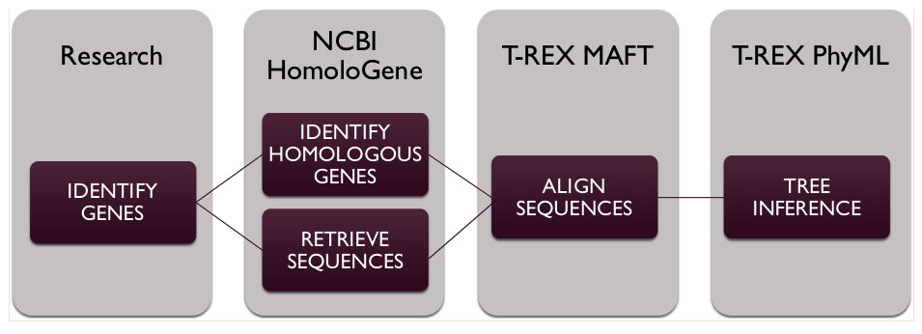

* **PubMed** – <https://www.ncbi.nlm.nih.gov/pubmed/>
  + Archive of biomedical articles
  + **Tutorial:** https://www.youtube.com/watch?v=ynTWoIiGwVo
* **GEO (Gene Ontology Consortium)** - <http://www.geneontology.org/>
  + defines concepts/classes used to describe gene function, and relationships between these concepts
  + **Tutorial:** <https://www.youtube.com/watch?v=xomrsz9CHxI>
* **ChEBI (Chemical Entitities of Biological Interest)** - <https://www.ebi.ac.uk/chebi/>
  + Molecular ontology and interactomics database that focuses on small chemical compounds
* **ChEMBL** - <https://www.ebi.ac.uk/chembl/>
  + Database for drugs, proteins, small molecules, and organic molecules
* **IntAct** – http://www.ebi.ac.uk/intact/
  + Molecular interaction database
  + Tutorial: <https://www.youtube.com/watch?v=Q4mAZxnBAg0>
* **Interactome 3D** - <http://interactome3d.irbbarcelona.org/>
  + web service for the structural annotation of protein-protein interaction networks
  + Tutorial:<https://www.youtube.com/watch?v=OLgSnFZ1pb8>
* **Coursera Course:** <https://www.coursera.org/specializations/bioinformatics>

Other Resources

**Scholarships**

* + Nebraska Scholarships: <https://www.educationquest.org/>
  + UNO Scholarships: <https://www.unomaha.edu/admissions/financial-support-and-scholarships/types-of-aid/scholarships/uno.php>
  + UNO College of IS&T Scholarships: <https://pki.nebraska.edu/new/pages/admissions/scholarships-financial-aid/>

**Young Professional Resources**

* + Gallup Strengths Finder Test: <https://www.gallupstrengthscenter.com/Purchase/en-US/Product>
  + Nebraska Internships: <http://internne.com/>
  + Interview Question Research: <https://www.glassdoor.com/index.htm>
  + UNO Student Interview Practice: <https://www.unomaha.edu/student-life/achievement/academic-and-career-development-center/career-development/interviewing-resources.php>
  + UNO Student Job Hunt:<https://www.unomaha.edu/student-life/achievement/academic-and-career-development-center/students/uno-career-connect.php>

